STAAR Online State Assessment Vs. the Kurzweil Text – to – Speech Program
STAAR Online | Kurzweil
STAAR Online  Text-to-Speech  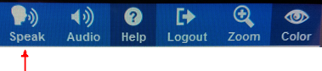  To have STAAR Online read out loud, the student clicks the “Speak” icon. A reading tool window pops up. From there they can click play, stop, or click word to hear single words read. They click close to close the reading tool window.  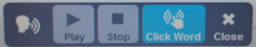 | Kurzweil  Text-to-Speech  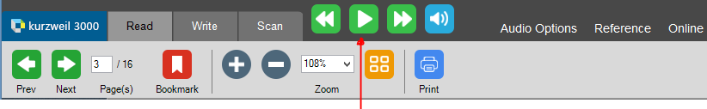  The Kurzweil read button is always present. To hear, the student clicks the read button. As it is reading, the play becomes pause . They click pause to stop. Alternatively, the student can click on the page to stop reading. If they want to go back or skip forward they click . They can also click on the page where they want to start reading, click read and it will read. To hear single words spoken, double click on the word. The is to turn on and off text-to-speech. The student can click the speaker button to turn it to silent . When they click read it only highlights to assist the student with tracking and does not read out loud. Click the icon again to turn on text-to-speech.
STAAR Online  Audio Options  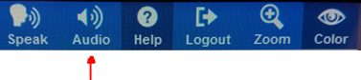  To change STAAR Online audio options, the student clicks the “Audio” icon. An audio settings tool window pops up (shown below). From there they can change volume and reading speed. 10 reading speeds available. STAAR Online currently has one voice available.  STAAR Online  Audio Options (continued)  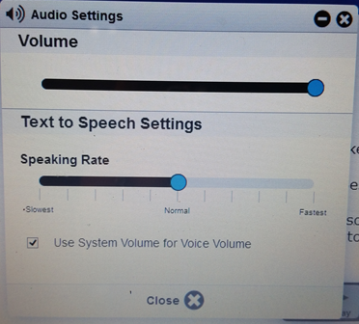 | Kurzweil  Audio Options  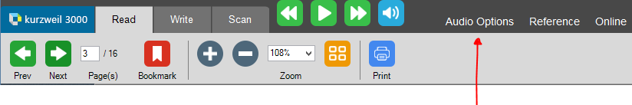  To change Kurzweil audio options, the student clicks the “Audio Options” menu. An audio options drop down appears to change the reading speed 60-540 WPM. Volume is changed at the computer, not in the Kurzweil program. Additional reading options available in Kurzweil: choice of reading voices, mode, units, and language reading.  Kurzweil  Audio Options (continued)  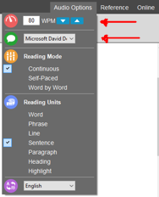
STAAR Online  Zoom  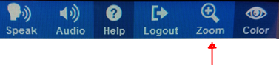  To change STAAR Online zoom options, the student clicks the “Zoom” icon. A zoom settings tool window pops up (shown below). From there they can change zoom and arrow across the page.  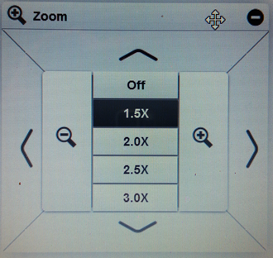 | Kurzweil  Zoom  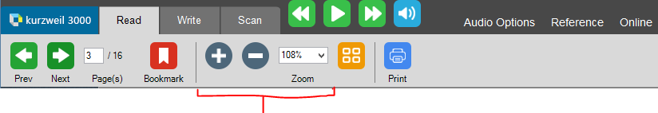  To change the zoom in Kurzweil, click the Zoom in or Zoom out . Students can also choose a certain page size via the dropdown window.  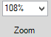
STAAR Online  Color Settings  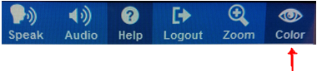  To change STAAR Online color options, the student clicks the “Color” icon. A color settings tool window pops up (shown below). From there they can change the background color or text color.  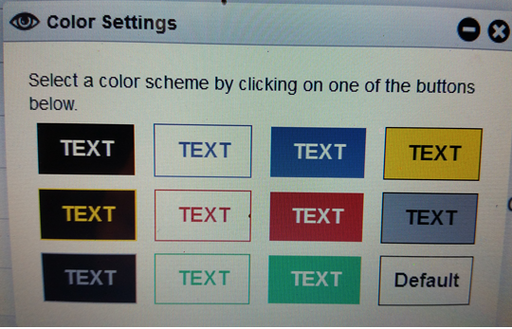 | Kurzweil  Color Settings  To change Kurzweil background color options: The teacher or student can click to add this tool to the left toolbar by right clicking on the toolbar, click “insert” ( at beginning/end or before/after), click “Tools”, then click “Change Background Color”. This will add the tools for students to change the color of the background . These are the colors that will display when user clicks on background color.  If the student is logged into their own Kurzweil account, it will remember their background color setting and they will not have to change them in other documents.
STAAR Online  Highlighter and Eraser  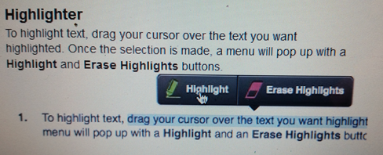  In STAAR Online, students left click and drag their mouse over the text to have the Highlight/ Erase Highlight menu appear. | Kurzweil  Highlighter and Eraser  In Kurzweil, students can select the highlighter or eraser in the left toolbar and drag their mouse over the text to Highlight or Erase highlight. Additional highlight colors and circle tools available when yellow highlighter is clicked on. The eliminator tool is visible at the right of choices.
STAAR Online  Notepad  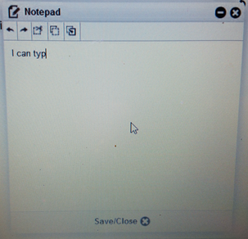  STAAR Online Notepad allows for taking note on each page. | Kurzweil  “Footnote” similar to “Notepad”  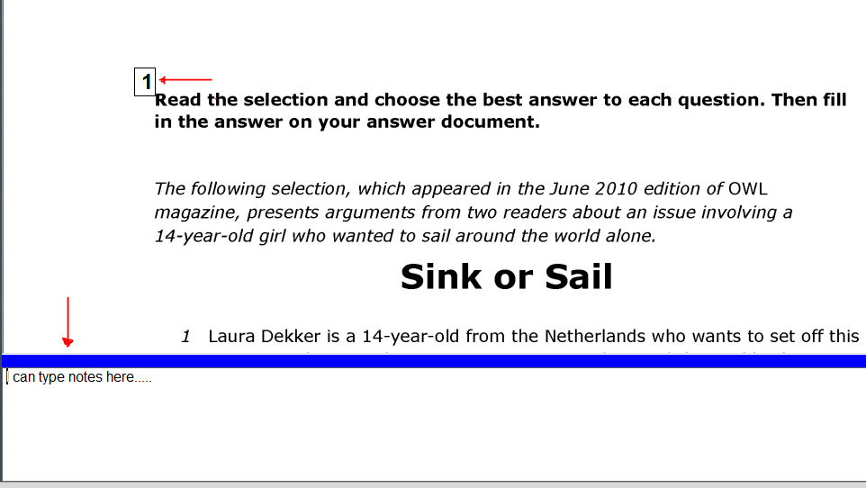  Footnotes is a similar tool in Kurzweil for the STAAR Online Notepad. Students can click Footnotes button in the left toolbar. The footnote box appears and students type. When they close the footnote, they can return to it by clicking on the footnote which will appear after they have created the note.
STAAR Online  Picture Support  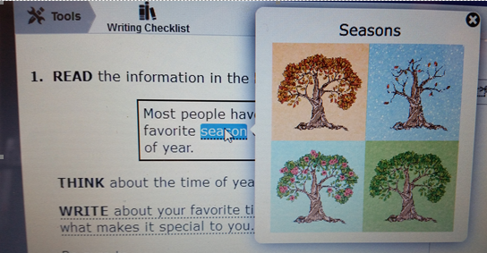 | Kurzweil  Picture Support  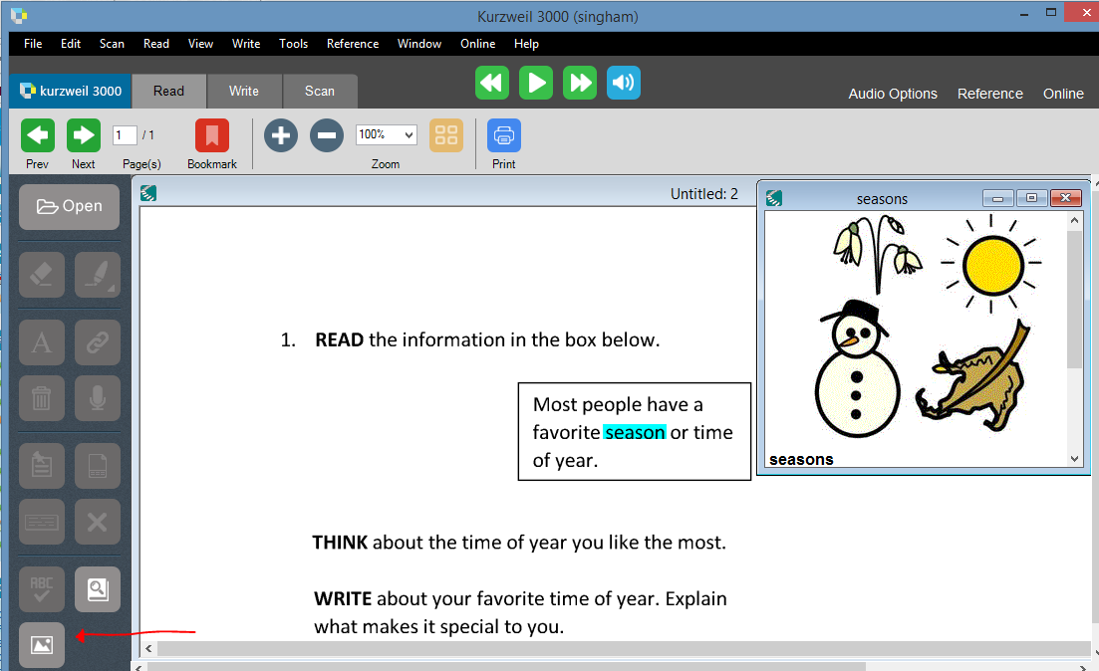  Students can get the picture of any word that has a picture available by clicking on the word then clicking the “Get picture of selected word button”. Alternatively, if you only want students to see specific pictures you can set a link to particular words by clicking on the word you want to embed picture support. Check to see that there is an available picture for that word, by clicking on the word and clicking the “Get Picture” button from the left toolbar. If the picture exists, close the picture and select the word in the text, then click the Hyperlink Button from the left toolbar. Next click “File” , click “Browse” to navigate to “Windows (C:)” drive, click “Program Files x86”, click “Kurzweil Education Systems”, click “Common Files”, and “Widgit Picture Dictionary”. Use the search window to find the picture you want. Once found, click on the picture you want to insert, then click “Open”. Finally, click “Add” to add the link. The word will be marked with a blue link line and when clicked, will display the picture.
STAAR Online  “Pop-ups”  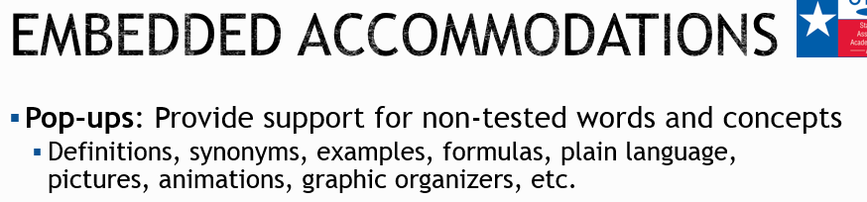  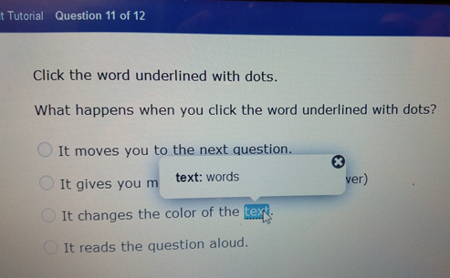  Sample of a pop-ups | Kurzweil  “Bubble Notes” similar to “Pop-ups”  Teachers can create bubble notes(similar to pop-ups) by placing their curser where they want to add the support, click dropdown menu “Tools”, “Notes”, click “Add Bubble Note”. Type the support. You can click options to not have Kurzweil read the bubble note or open unless prompted by student. Once finished, click “Ok”. You will see a marking where a support is embedded. When double clicked, the support opens. NOTE: Bubble notes is also what you would use for roll-overs, though it will not roll over the text.  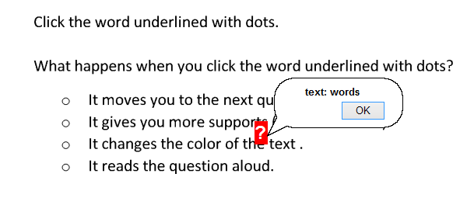
STAAR Online  Scaffolding questions with roll-overs  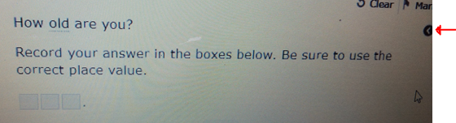  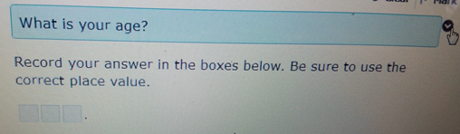  Sample of a roll over | Kurzweil  Scaffolding or reword questions with Bubble Notes  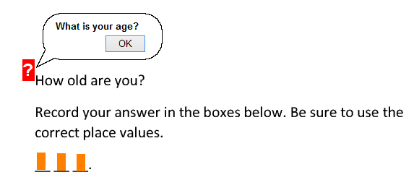  Sample of bubble note.  Note: Teachers and students can also fill in blanks using Kurzweil’s “Add a text note” tool from Kurzweils reading left toolbar. Blank text notes marked as orange boxes. Students click and type.
STAAR Online Calculator  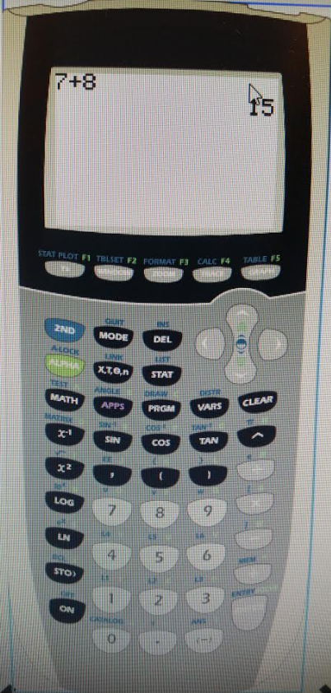  To view the calculator, students click on the calculator icon to display the above calculator. The calculator does not speak as the student types in it. | Kurzweil  Calculator  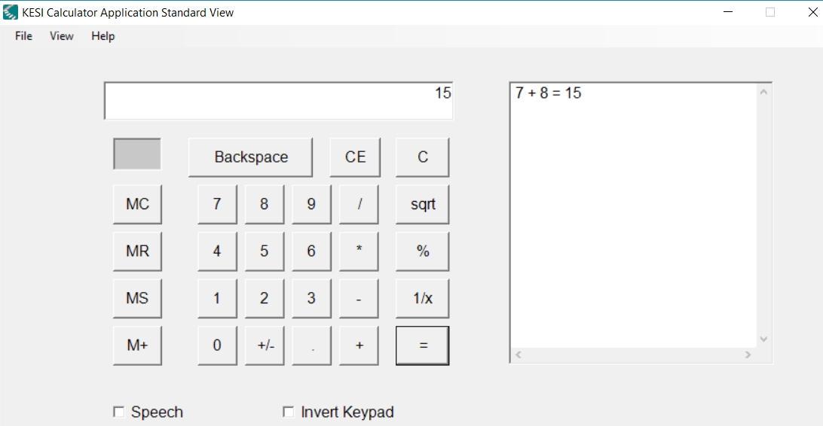  Students have access to 4 talking calculators in Kurzweil 3000 (Scientific, Statistics, Standard, and Business). The standard toolbar is shown above. The calculator button can be added to the right toolbar by right clicking on the left toolbar, click one of the “Insert…” position options, click “Tools”, and “Calculator”
Kurzweil
Edit to read material ONLY allowed
Teachers can mark zone as silent to make those sections not read using our “zone editor”. To edit what is read/not read, you need to have the Scan tab selected to expose your editing tools. Click the Zone Edit button in the top toolbar. This will expose what/when it reads. You can double click on a zone, then put a check in the box “Silent.” Repeat for each zone that you do not what to be read. You can also right click, to open your other zoning options (delete zone, delete all zones, properties “to change reading order”, adjust zone, add zone).To turn off zone editor, click the zone edit button and click “yes” to each notification messages. Zone each page of the document, then Edit the Underlying Text (shown in next section) if recognition errors are present, then add supports if needed (bubble note). To still access highlighters on removed text, leave in zones but delete underlying text shown below.
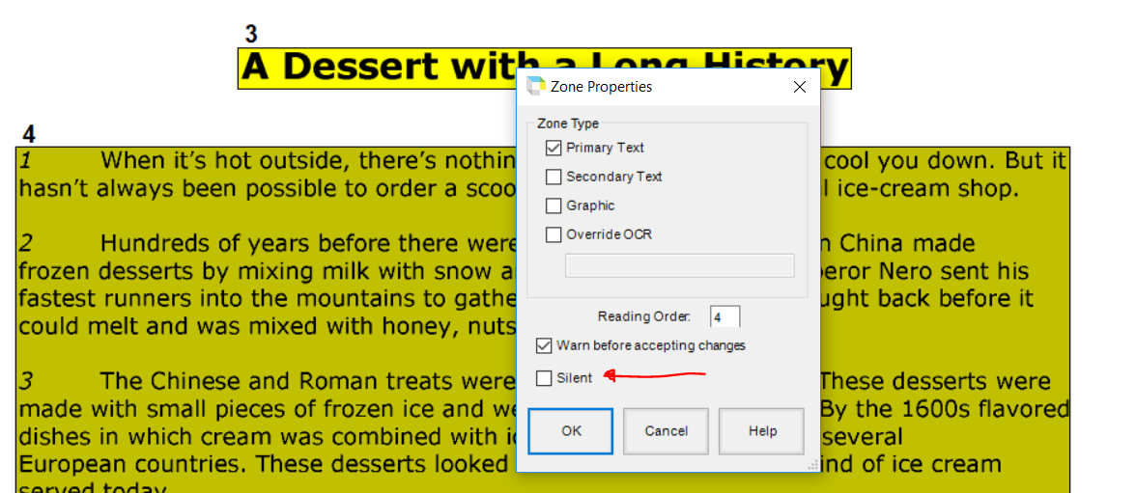
Kurzweil
Edit Recognition Errors

Teachers can edit text when words are not recognized correctly or as they should be read. To edit the words under the image, you need to have the Scan tab selected to expose your editing tools. To edit a recognition error, click the “Edit Underlying Text” button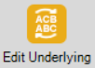 in the top toolbar. Scroll and type changes in the boxes below the image (as shown below). When finished editing, click to close out the underlying text box, then click yes to save changes. If there is a common reoccurring error, such as in math “x” means “times” you can do a search and replace all. This is done by going to dropdown menu “Edit”, “Find”, and “Replace Text”. Be sure to choose Case Sensitive and Match Whole Word. Tip: Alternatively, in math, you could zone out the equation to not read it and/or insert a Voice Note, to record your own voice reading the equation.

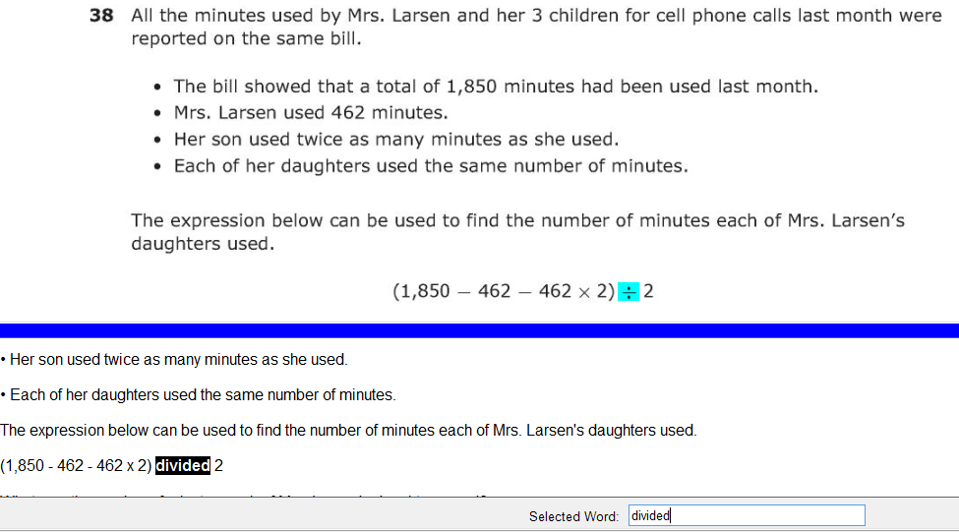
Kurzweil
Adding Stop Marks
Teachers can add stop marks using the Add Text Note button (hidden tip). To add empty text note you need to have the Reading tab selected to expose your reading tools. Click on “Add Text Note button” in the side toolbar, then click where you want it to stop. Empty text note will appear. Repeat this every where you want a pause. When the student wants to go on, they click read. This is helpful on pages where you have omitted readable text and the student is to read on their own. Also, placing this marker after each question might be helpful to the student. (Idea provided by Humble ISD)

Kurzweil
Customizing the Toolbar in Documents

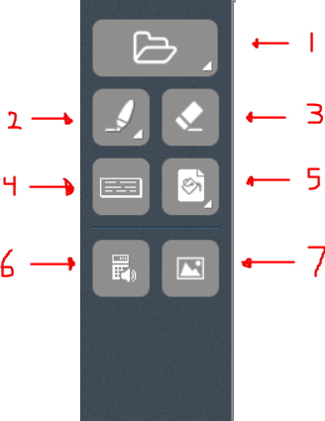
Teachers can create customized toolbars to save to documents/tests. Above shows a sample toolbar that gives students some of the tools similar to STAAR (1-Open, 2-Highlighter and eliminator tool, 3-Eraser, 4-Footnote “similar to note pad, 5-Background Color “overlay”, 6-calculator, 7-picture support dictionary).

To edit the left toolbar, right click on a tool to 1) delete tools or 2) add tools in front or behind other tools. To save a custom toolbar you have created to your profile to use later, right click on a blank part of the left toolbar, click “Save Toolbar Set” and name the tool bar. The toolbar will then show up in the list when you right click over the left toolbar, then click “Load a Toolbar Set”. To save a toolbar in a document, see below section on Saving Lock Features and Password Protect document.
Kurzweil
Save Lock Features, Toolbar and Password Protect document

Teachers can lock features in documents to not be accessible or turned on during tests. This can be done by going to dropdown menu “Tools”, “Lock Features” and disabling the features.
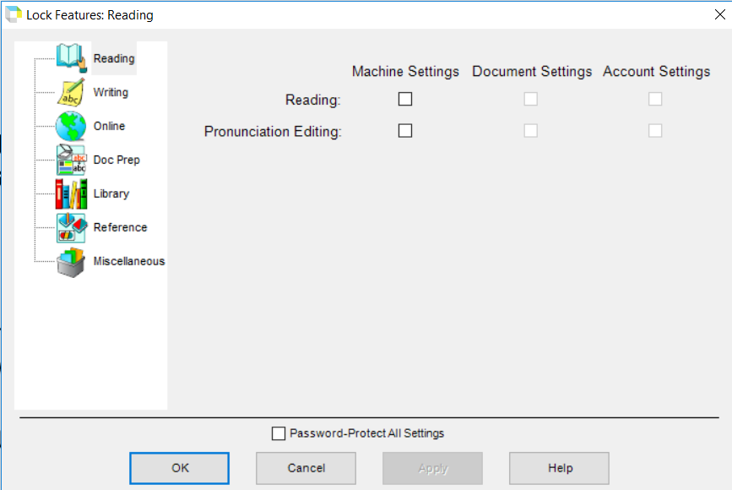

The lock features can then be saved to the document by going to dropdown menu “File”, “Properties”, and selecting “Save Feature Locks in document” and any other properties you want to apply, such as “Save Toolbars in Document”. Teacher can password protect the document as well from here. NOTE: You may want to save an unlocked version of the test as well. Once you have locked features in the document, they cannot be unlocked.
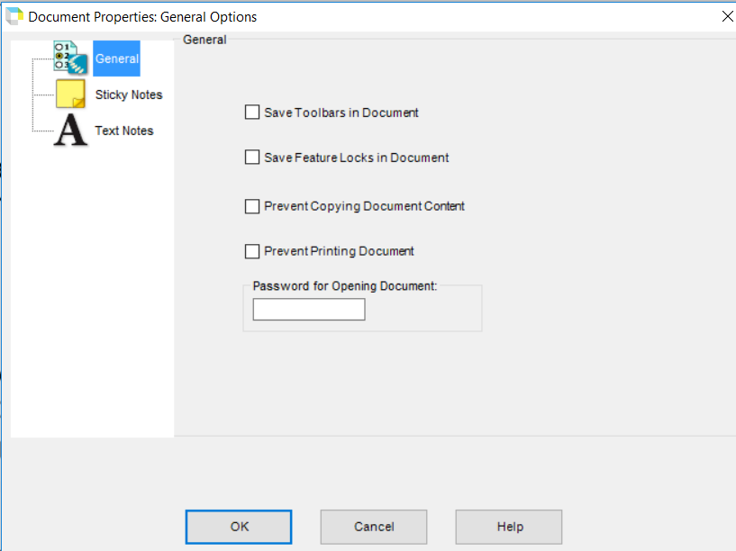
Kurzweil (Web version only)
Lock Features of student profiles “alternative to locking document properties”

PLEASE USE CAUTION when locking student profiles out of features. If a teacher does not remember to unlock the system features, the student will be locked out until someone unlocks the features back on. Some school have prohibited teachers from using feature profile locks for this reason, so check with your school. To lock feature of student(s), that student must be on that teacher’s team. Login at www.kurzweil3000.com, go to “My Account” tab, click “Users”, then click “My Team” . Click on Feature Locks or Miscellaneous Feature Locks to display and lock features for certain students 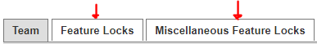.

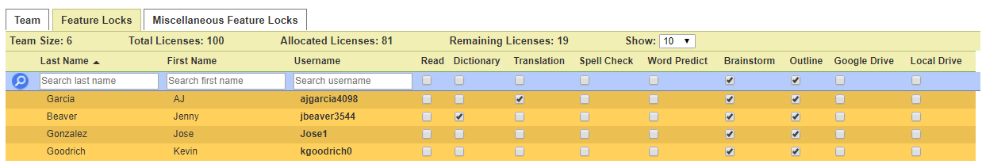

OTHER SUPPORTS
Kurzweil :
Students have access to a variety of supports from the “Reference” link in the top right corner.
Definitions, Synonym, Syllables, Picture supports  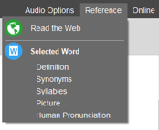 |  | Online Resources Includes search for Book, Magazine, Online Encyclopedias, and Language Translation  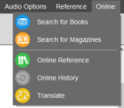
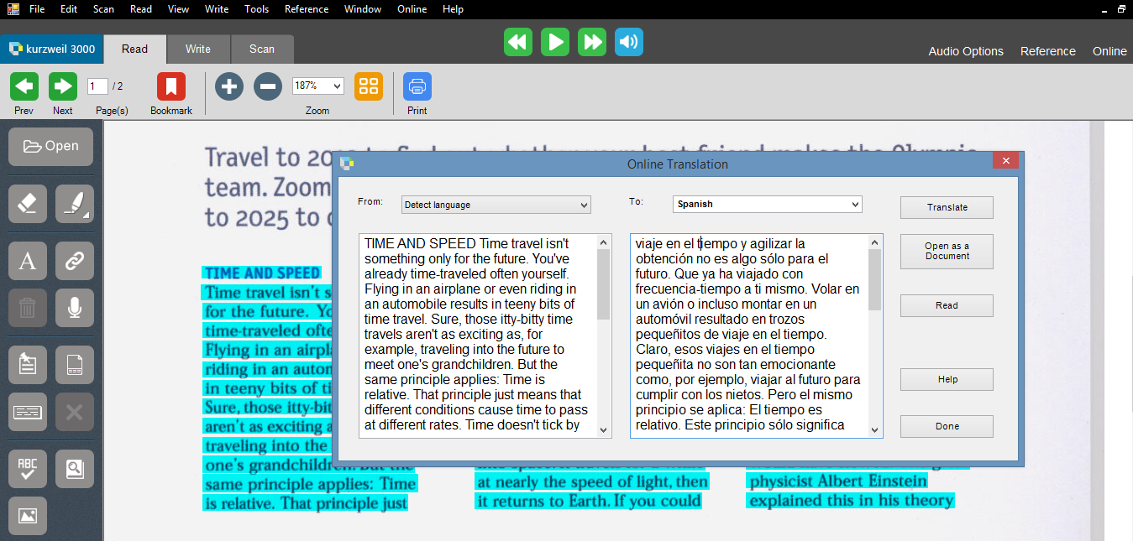
For language translation, students select the text, click the dropdown menu “Online”, and click “Translate” to translate from English to one of 80 languages. Kurzweil will read only 11 languages of the 80 languages it visually translates.
Audio Optical Systems of Austin
Ph# 512-454-8672
Email: aos@kurzweilaustin.net
www.kurzweilaustin.net
Created and revised by Stephanie Ingham 10/17/2016

